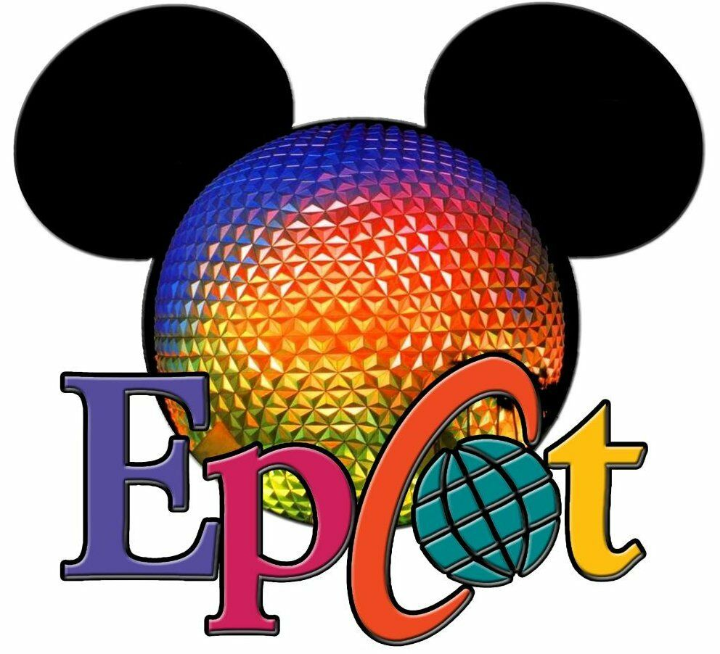
Today our trip takes us to Walt Disney World in Orlando Florida and EPCOT. Here is a list of some rides for us to ride. Go to www.youtube.com and search for each of these rides under Walt Disney World rides and the ride’s name. Example: Walt Disney World Spaceship Earth. When you are finished watching, write down which ride you like the best and why.

- Spaceship Earth 6. Soarin
- Ellen’s Energy Adventure (long) 7. Living with the Land
- Mission: SPACE 8. Journey into Imagination
- Test Track 9. Frozen Ever After
- The Seas with Nemo and Friends 10. Gran Fiesta Tour with 3 Caballeros

Bonus questions:
Can you tell me what EPCOT stands for?
In what ride do you hear the phrase “Remember how easy it was to learn your ABC’s thank the Phoenicians”?

